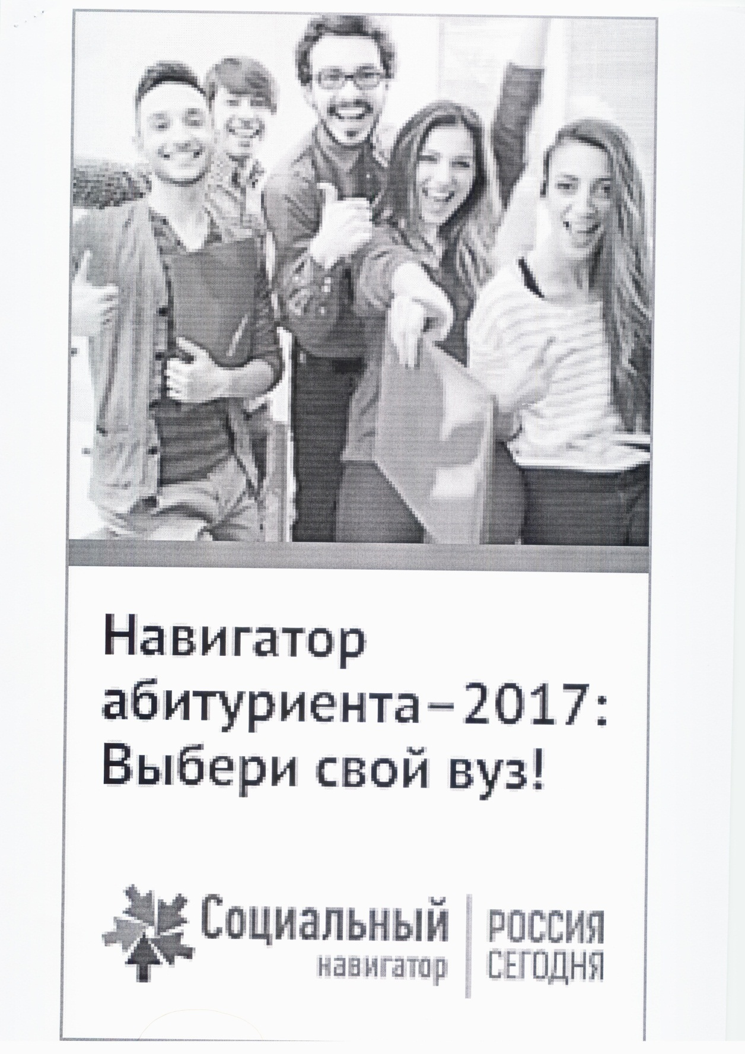
http://ria.ru./abitura_rus/20170320/1488838853.html

